1. Given the provided data, what are three conclusions we can draw about Kickstarter campaigns? Explain the reasoning behind your answers.

**- Kickstarter campaigns are most successful (63%) when the goals are less than 10,000.**

: Downward linear trends of goal numbers and percentages of successful campaigns show that goals that

are less than 10,000 has the highest success rate.

: Chance of failure increases as number of goals increases.

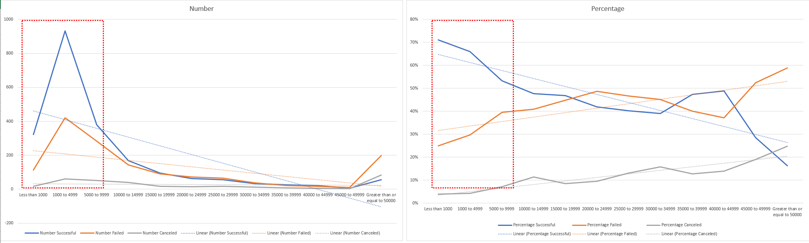

*(Original graphs can be found in sheet “Bonus”)*

**- Music Category has the highest successful rate compared to other categories.**

: (by Top-3 success rate) Music 77%, Theater 60%, Film & Video 58%.

**- Every successful Kickstarter campaign is funded greater than or equal to 100%.**

: Of the 2,185 successful campaigns, 2,185 were funded greater than or equal to 100% of goals.

2. What are some limitations of this dataset?

- 89% of Kickstarter campaigns are U.S. and Great Britain (U.S. 74%, Great Britain 15%), so successful campaigns

in this dataset may not accurately represent other countries.

: For example, Netherland (DE) has technology as the highest successful campaign category (53%).

- Different currencies from listed countries make it more difficult to compare overall funding and Average

Donation (13 currencies).

3. What are some other possible tables and/or graphs that we could create, and what additional value would they provide?

- Clustered column chart with row as “Date Duration” and column as “State” provides an insight that 66% of

projects were successful before or at 30 days after launch.